Spearman rank correlation: USDJPY and USDCAD
Method 02 / daily log returns / Alpari D1 full available history

Study setup
Logical pair: USDJPY , USDCAD
Broker symbols: USDJPY_i , USDCAD_i
Snapshot: 2026-11-03_majors_alpari_D1
Timeframe: D1
Matched return window: 1999-01-05 to 2026-11-02 (UTC bar dates)
Matched return count n: 7186
Dropped unfinished last bar dated 2026-11-03 UTC after a tick-volume check against the prior complete day.
Complete matched rows (CSV): USDJPY-USDCAD_Spearman_D1.csv
Complete matched rows (HTML table): USDJPY-USDCAD_Spearman_D1_data.html

Method carried forward
Spearman rho is Pearson correlation on the ranks of matched daily log returns of close, ln(close_t / close_t-1), in the broker quote direction. Ties use average ranks. Quotes are not inverted. rho is symmetric under swap of the two symbols. rho = 0 means no consistent rank-order link in this sample; it does not mean no link of any kind. The score is not a cause, not a lead, and not a trading signal. Daily rows are not independent draws, so the two-sided p-value and approximate Fisher interval are reported and treated as secondary to rho. Same-sample Pearson r is shown only as a side check; a large rho minus r gap can flag outliers or a non-straight link.

Results
Spearman rho: 0.100814
Two-sided p-value: 1.06775e-17
Approximate 95% Fisher interval: [0.077874, 0.123648]
Same-sample Pearson r: 0.027603
rho minus r: 0.073211

Conclusion
Over 7186 matched daily log-return rows for USDJPY and USDCAD (broker quote directions unchanged), Spearman rho is 0.1008 (positive, weak rank-order association in this sample). Approximate 95% Fisher interval: [0.0779, 0.1236]. Same-sample Pearson r is 0.0276 (rho minus r = 0.0732). Two-sided p under the usual independent-ranks model is 1.068e-17; that model does not match linked daily FX returns, so treat p as secondary. This does not establish cause, lead-lag, or a lasting trading rule.

Charts
Daily closes

Daily log returns
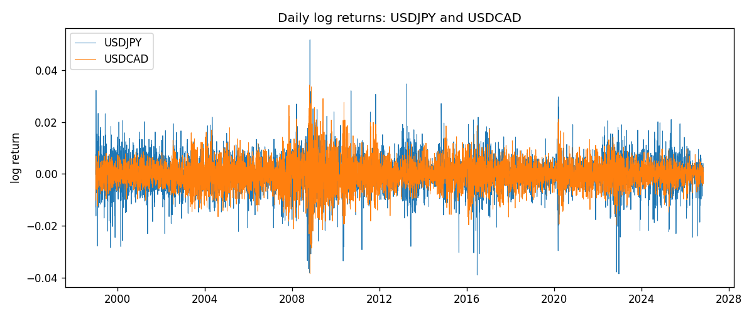
Log-return scatter
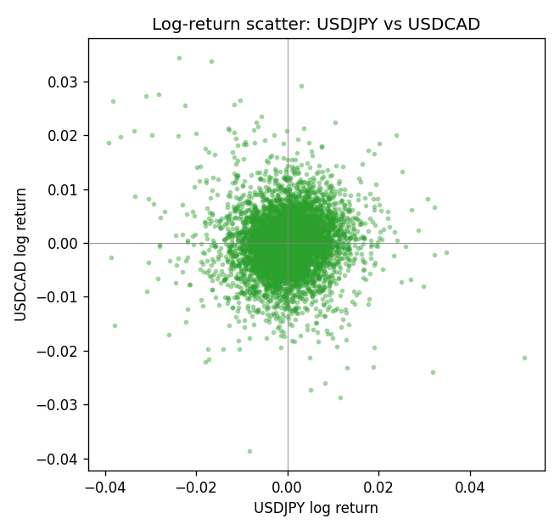
Rank-rank scatter
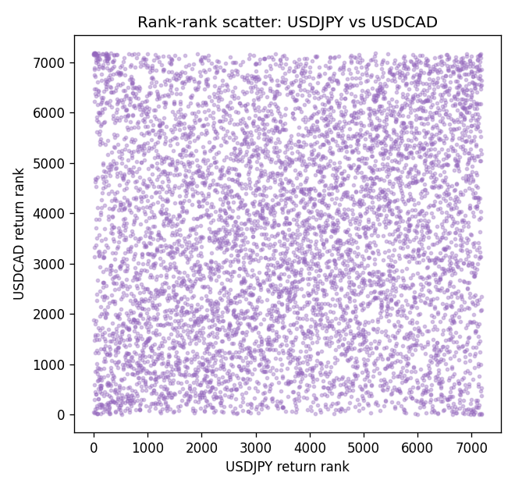

Data report
Every matched row that entered Spearman rho is stored in the sibling CSV named USDJPY-USDCAD_Spearman_D1.csv. That file is the complete data archive for redrawing charts. Embedding all rows as a Word table is impractical at this length; the Word file holds the column list, column summaries, and the first and last 15 matched rows.
Columns: time, USDJPY_open, USDCAD_open, USDJPY_high, USDCAD_high, USDJPY_low, USDCAD_low, USDJPY_close, USDCAD_close, USDJPY_tick_volume, USDCAD_tick_volume, USDJPY_spread, USDCAD_spread, USDJPY_real_volume, USDCAD_real_volume, USDJPY_log_return, USDCAD_log_return
Column summaries (matched calculation rows)
column | count | mean | std | min | 25% | 50% | 75% | max
USDJPY_open | 7186 | 113.80748 | 19.222412 | 75.693 | 104.39025 | 110.981 | 120.70625 | 163.824
USDCAD_open | 7186 | 1.266789 | 0.16892251 | 0.9168 | 1.118445 | 1.2985 | 1.37213 | 1.6183
USDJPY_high | 7186 | 114.30511 | 19.284087 | 76.001 | 104.8685 | 111.4395 | 121.2675 | 163.978
USDCAD_high | 7186 | 1.2716872 | 0.16888037 | 0.9336 | 1.122975 | 1.303895 | 1.37655 | 1.619
USDJPY_low | 7186 | 113.28446 | 19.150257 | 75.402 | 103.88 | 110.53 | 120.1715 | 163.628
USDCAD_low | 7186 | 1.2622311 | 0.16895752 | 0.9056 | 1.114125 | 1.293555 | 1.367815 | 1.6102
USDJPY_close | 7186 | 113.82065 | 19.237762 | 75.811 | 104.38275 | 111.018 | 120.69375 | 163.851
USDCAD_close | 7186 | 1.2668036 | 0.16889539 | 0.916 | 1.118165 | 1.29848 | 1.372395 | 1.6137
USDJPY_tick_volume | 7186 | 106329.64 | 179429.89 | 149 | 9948.5 | 53187 | 92874.5 | 1803508
USDCAD_tick_volume | 7186 | 81037.769 | 147318.12 | 37 | 5546.5 | 40944 | 71631 | 1410818
USDJPY_spread | 7186 | 20.270804 | 17.617829 | 0 | 6 | 11 | 30 | 50
USDCAD_spread | 7186 | 23.436682 | 18.263202 | 0 | 9 | 17 | 40 | 60
USDJPY_real_volume | 7186 | 3.4776211e+10 | 1.6092546e+11 | 0 | 0 | 0 | 0 | 3.8834203e+12
USDCAD_real_volume | 7186 | 1.8381818e+10 | 9.6701063e+10 | 0 | 0 | 0 | 0 | 2.5751613e+12
USDJPY_log_return | 7186 | 5.053e-05 | 0.00620694 | -0.03908203 | -0.00319936 | 0.00011986 | 0.0034094 | 0.05184024
USDCAD_log_return | 7186 | -1.555e-05 | 0.00514357 | -0.03859748 | -0.00283709 | 4.741e-05 | 0.00272359 | 0.03436319
First 15 matched rows (selected columns)
time | USDJPY_close | USDCAD_close | USDJPY_log_return | USDCAD_log_return | USDJPY_tick_volume | USDCAD_tick_volume
1999-01-05 | 111.92 | 1.5123 | -0.00017868311 | -0.010131666 | 6367 | 1345
1999-01-06 | 112.77 | 1.5118 | 0.0075660159 | -0.0003306769 | 6225 | 1803
1999-01-07 | 111.33 | 1.5141 | -0.012851583 | 0.0015202092 | 6671 | 1568
1999-01-08 | 110.8 | 1.511 | -0.0047719894 | -0.0020495197 | 10700 | 914
1999-01-11 | 109.02 | 1.5057 | -0.016195423 | -0.0035137769 | 9168 | 953
1999-01-12 | 112.6 | 1.5157 | 0.032310364 | 0.0066194721 | 10131 | 1507
1999-01-13 | 113.52 | 1.5226 | 0.0081373171 | 0.0045420214 | 7265 | 2141
1999-01-14 | 113.52 | 1.5332 | 0 | 0.0069376546 | 6335 | 1816
1999-01-15 | 114.15 | 1.5245 | 0.0055343401 | -0.0056905671 | 5479 | 1897
1999-01-18 | 114.16 | 1.526 | 8.7600193e-05 | 0.00098344542 | 5482 | 1091
1999-01-19 | 113.52 | 1.5302 | -0.0056219403 | 0.002748513 | 5702 | 1634
1999-01-20 | 112.91 | 1.5211 | -0.0053879917 | -0.0059646885 | 5919 | 1499
1999-01-21 | 113.87 | 1.5146 | 0.0084664056 | -0.0042823796 | 6251 | 2007
1999-01-22 | 114.56 | 1.5184 | 0.0060412564 | 0.0025057712 | 5453 | 1713
1999-01-25 | 113.72 | 1.5197 | -0.0073594164 | 0.00085579808 | 4696 | 1471
Last 15 matched rows (selected columns)
time | USDJPY_close | USDCAD_close | USDJPY_log_return | USDCAD_log_return | USDJPY_tick_volume | USDCAD_tick_volume
2026-10-13 | 158.305 | 1.4214 | -0.0018932826 | -0.0046395653 | 81731 | 50947
2026-10-14 | 158.317 | 1.42356 | 7.5800166e-05 | 0.0015184751 | 95596 | 56126
2026-10-15 | 158.024 | 1.41843 | -0.0018524319 | -0.0036101503 | 115120 | 63096
2026-10-16 | 157.964 | 1.41357 | -0.00037976126 | -0.0034322068 | 86475 | 54908
2026-10-19 | 158.517 | 1.41091 | 0.0034946841 | -0.0018835331 | 70872 | 52155
2026-10-20 | 158.16 | 1.40569 | -0.0022546642 | -0.0037066008 | 82689 | 54450
2026-10-21 | 158.108 | 1.4045 | -0.00032883504 | -0.00084691787 | 67431 | 51369
2026-10-22 | 156.755 | 1.40081 | -0.0085942669 | -0.0026307268 | 100312 | 58806
2026-10-23 | 156.81 | 1.40085 | 0.00035080446 | 2.85545e-05 | 103374 | 50387
2026-10-26 | 157.458 | 1.40093 | 0.0041238746 | 5.7106554e-05 | 87120 | 49601
2026-10-27 | 157.894 | 1.40449 | 0.0027651658 | 0.0025379458 | 72962 | 49541
2026-10-28 | 157.743 | 1.39911 | -0.00095679538 | -0.0038379274 | 72076 | 56077
2026-10-29 | 157.683 | 1.39895 | -0.00038043789 | -0.00011436495 | 88229 | 59551
2026-10-30 | 157.516 | 1.39751 | -0.0010596481 | -0.0010298736 | 106706 | 59373
2026-11-02 | 157.933 | 1.39837 | 0.0026438521 | 0.00061519094 | 80702 | 53578

